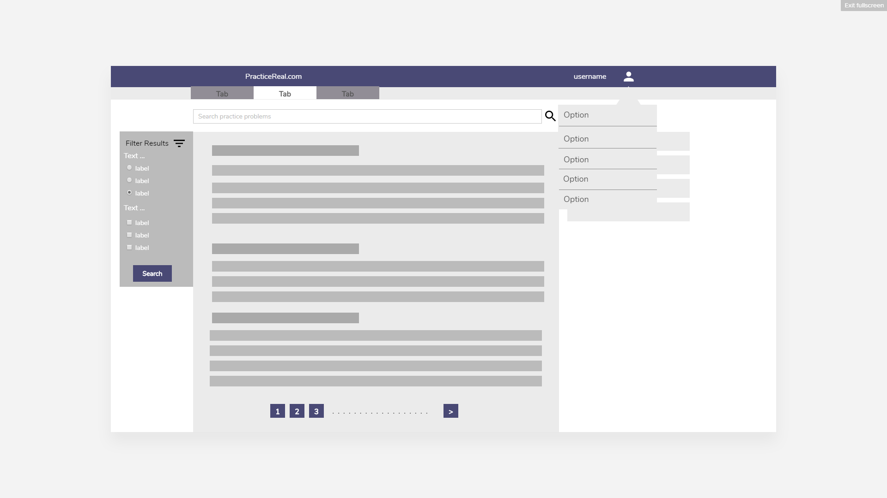

PracticeReal.com

It is a website which allows students to find real world problems to solve as practice problem. The companies post the tasks and student solve them for training.

Demo:

<https://preview.uxpin.com/a838e922e4687a84df6b34616703d10144d8bc7c#/pages/83115475/simulate/no-panels?mode=i>